34.30: We have a converging lens if the focal length is positive, which requires:
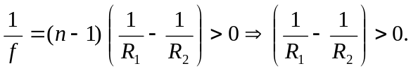 This can occur in one of three ways:
(i)
(iii) 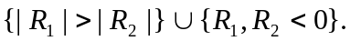Hence the three lenses in Fig. (35.29a).
We have a diverging lens if the focal length is negative, which requires:
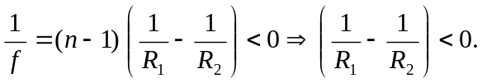 This can occur in one of three ways:
Hence the three lenses in Fig. (34.29b).

